SPLASH MENU
TERM THREE – 2023
WEEK 6 TO WEEK 10

MONDAY | TUESDAY | WEDNESDAY | THURSDAY | FRIDAY
Ham and pineapple pizza Lebanese bread | Sao ham and cheese tomato | Napolitana pasta | Fruit salad with yoghurt and arrowroots biscuit | Spread on bread
 | 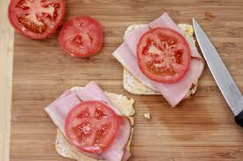 | 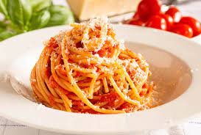 |  | 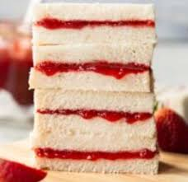
Vegan cheese  Gluten free base | Vegan curry | Gluten free pasta | Vegan yoghurt  Gluten free biscuit  Gluten free yoghurt | Gluten free bread
WEEK 7
Cheese scrolls | Bbq chicken wrap | Cheese toadies | Beef Nacho | Sausage sizzle
 | 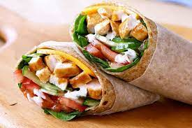 | 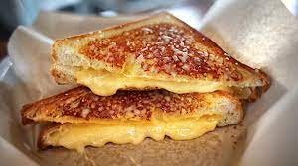 | 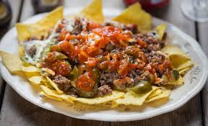 | 
Gluten free pastry and bio cheese for vegan | Vegetarian wrap  Bio cheese | Bio cheese and gluten free bread | Gluten free corn chip  Vegan nacho | Vegan sausages  Gluten free bread

WEEK 8
Ham, cheese and cucumber sandwich | Butter chicken | Fried rice with bacon and veggies | Chicken soup | Chicken Nuggets
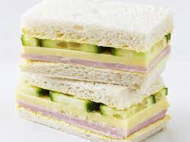 | 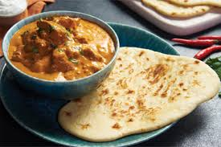 | 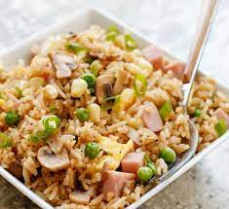 | 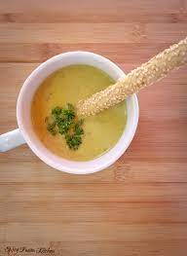 | 
Gluten free bread |  | Vegan fried rice and gluten free sauce | Vegan soup/ gluten free bread sticks | Gluten free nuggets  Vegan nuggets
WEEK 9
Corn chips and Dip with veggie sticks | frankfurt | Chicken and potato curry | Vegetarian Hokkien noodle | Cheese toastie
 | 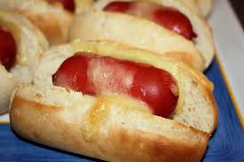 |  | 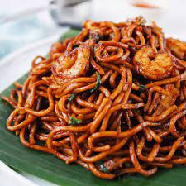
Gluten free corn chips  Hummus | Gluten free bread  Vegan frankfurt | Vegan butter chicken |  | Gluten free bread and bio cheese

WEEK 10
Sausage sizzle | Cheese scroll | Lebanese bread with dips | Napolitana pasta | Jatz with cheese
 |  | 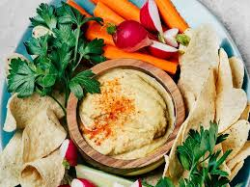 |  | 
Gluten free breads  Vegan sausage | Glutem free pastry  Bio cheese | Gluten free wrap | Gluten free pasta

