SPLASH MENU
TERM ONE – 2024
WEEK 9 & WEEK 10

MONDAY 25/03 | TUESDAY 26/03 | WEDNESDAY 27/03 | THURSDAY 28/03 | FRIDAY 29/03
Fruit salad with arrowroot biscuits | Bbq chicken wrap | Cheese toasties | Corn chips with dip and veggies sticks
 | 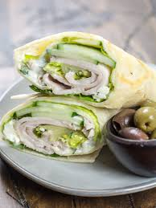 | 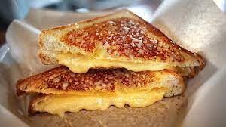 |  | GOOD FRIDAY
Pears and apples | Apple and oranges | Melon and apple | Pears and oranges
Gluten free noodles  Vegan noodles | Gluten free wrap | Gluten free bread  Bio cheese
WEEK 10
MONDAY 01/04 | TUESDAY 02/04 | WED 03/04 | THURSDAY 04/04 | FRIDAY 05/04
 | Corn thin with ham cheese and veggies | Rice with spring rolls | Bread with spreads | Cheese and crackers
EASTER MONDAY | 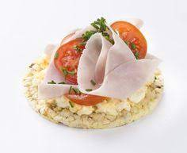
 | Gluten free corn thin | Vegetarian spring rolls | Gluten free bread | Gluten free crackers  Bio cheese
 | Melon and apples | Oranges and pears | Watermelon and apples | Oranges and pear

